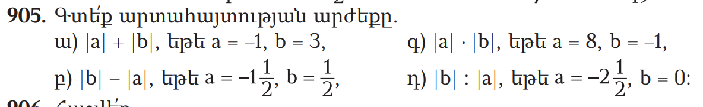
|a|+|b|=|1|+|3|
1 + 3 = 4
|b| - |a| = |3/2| - |1/2|
1/2 – 3/2 = -2/2 = -1/1 = -1
|a| x |b| = |8| x |1|
8 x 1 = 8
|b| : |a| = |5| : |0|
5 x 0 = 0
(-7 3/5) + (-3 2/5) = (-38/5) + (-17/5) = (55/5) + (4 2/7) = (-11/1) + (-30/7) = (-77/7) + (-30/1) = (-107/7)
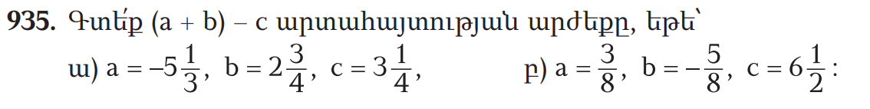
(-5 1/3) + (2 3/4) - (3 1/4) = (-16/3) + (8/4) – (12/4) =

